Requirement:

A company works with number of employees, all the works are dependents on the employees. Even if one of the employees resign the job immediately then assigned work will be not finished at the time, so delivery of the project to the clients will be delayed. Company planned to make solution for this, they want to know which employee may resign next. If they know previously, they can arrange alternative to avoid such problem. As an AI Engineer you must give Solution to this. A) How will you achieve this in AI? B) Find out the 3 -Stage of Problem Identification C) Name the project D) Create the dummy Dataset.

**Project :** Employee Retention Program

**Employee Data (Input):**

|  |  |  |  |  |  |  |
| --- | --- | --- | --- | --- | --- | --- |
| EmployeeId | Age | Gender | Years of Service | Salary | Distance to Work in Kms | Skills Rating |
| 1054 | 30 | F | 7 | 200000 | 20 | 8 |
| 2086 | 55 | M | 25 | 1000000 | 5 | 8 |

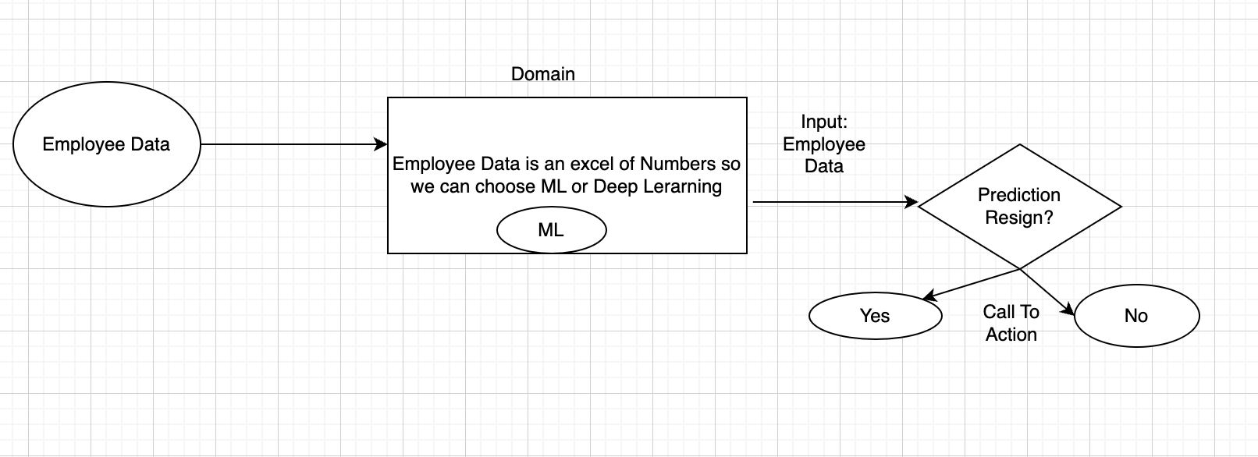

**Domain: Machine Language (because of Excel Data of numbers)**

**Input: Employee Data**

**Output: Yes/No (Resignation**)

Clear Input/ Output . Supervised Learning

|  |  |  |  |  |  |  |  |
| --- | --- | --- | --- | --- | --- | --- | --- |
| EmployeeId | Age | Gender | Years of Service | Salary | Distance to Work in Kms | Skills Rating | Output(Resignation) |
| 1054 | 30 | F | 7 | 200000 | 20 | 8 | Y |
| 2086 | 55 | M | 25 | 1000000 | 5 | 8 | N |

**Subtype: Classification**

**Suggested Domain: ML/Supervised/Classification**